**Milestone 2 - Project Plan for Grocery Store Billing and Inventory Management System**

**1. Entity-Relationship Diagram (ERD)**

The Entity-Relationship Diagram (ERD) for the Grocery Store Billing and Inventory Management System represents the relationships between the different entities in our system. The primary entities are **Customer**, **Product**, **Order**, **Supplier**, and **Inventory**. This diagram shows how these entities interact with each other and the cardinality constraints.

* **Customer** can place multiple **Orders**.
* **Order** consists of multiple **Products** via **OrderDetails**.
* **Product** is supplied by multiple **Suppliers**.
* **Inventory** tracks the stock levels of each **Product**.

**ERD Drawing Required:**

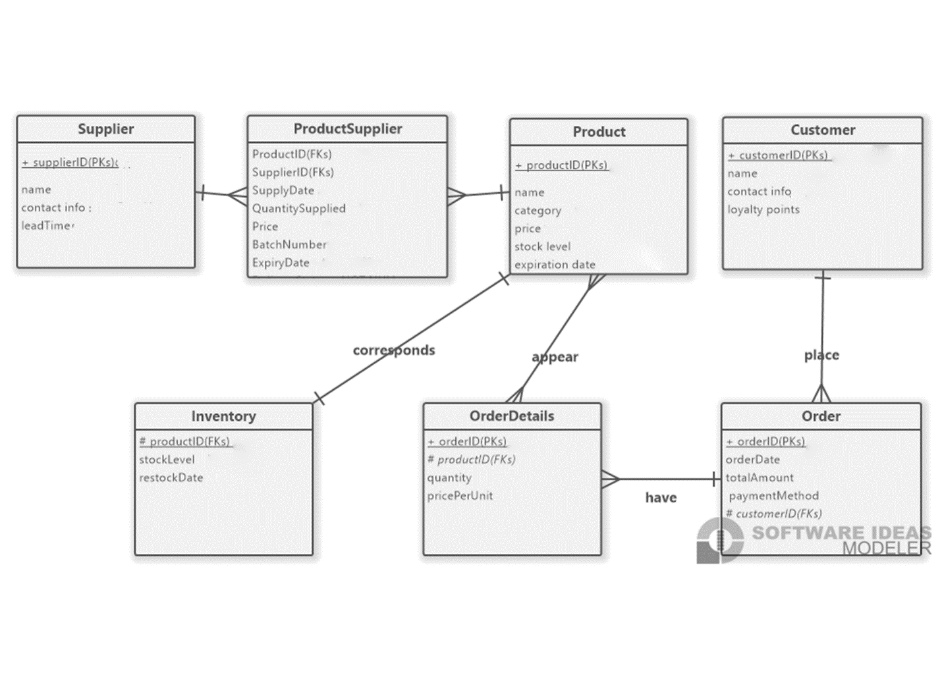

**2. Data Flow Diagram (DFD)**

**Context Diagram (Level 0)**

The level 0 diagram illustrates the entire system at a high level. It shows how external entities like **Customer**, **Supplier**, and **Manager** interact with the system through various processes such as **Order Processing**, **Inventory Management**, **Billing**, and **Data Reporting**.

* **Customer** interacts with the system through order placement and billing.
* **Supplier** provides inventory and updates stock.
* **Manager** uses the system for data reporting and managing stock levels.

**DFD Level 0 :**

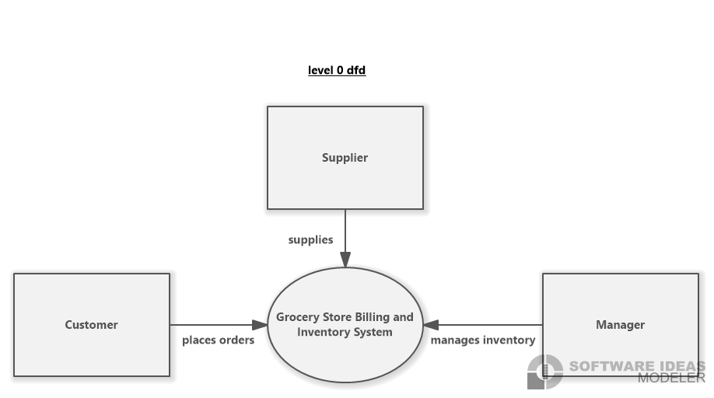**Level 1 Diagram**

In the Level 1 DFD, we break down the major processes:

1. **Order Processing**: Captures customer order data and updates the billing system.
2. **Inventory Management**: Tracks stock levels, restocking, and expiration dates.
3. **Generate Sales Report**: Processes payments and generates receipts.
4. **Data Reporting**: Provides real-time reports to the manager.

**DFD Level 1 Drawing Required:**

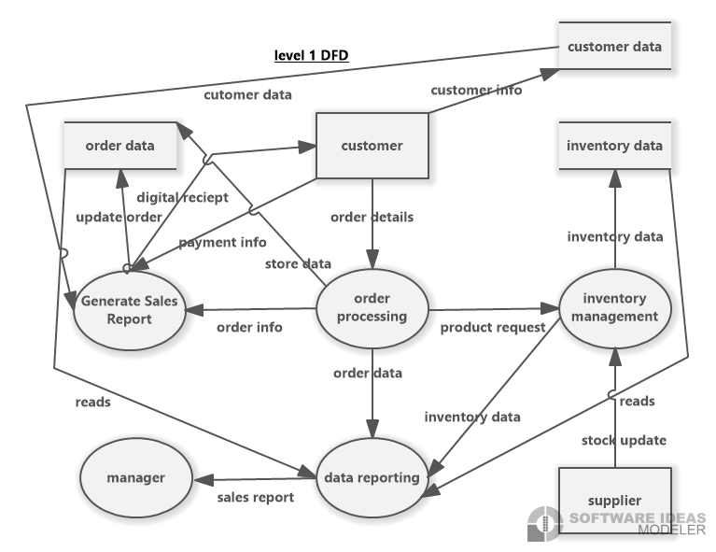

**3. Task List**

The project consists of multiple tasks divided into phases to ensure proper execution. Each phase contributes to completing the project within the proposed timeline of 12 weeks.

**Phase 1: Requirements Gathering & Design (3 Weeks)**

* **Task 1.1**: Gather requirements from stakeholders.
* **Task 1.2**: Design the Entity-Relationship Diagram (ERD).
* **Task 1.3**: Design the Data Flow Diagrams (DFD).

**Phase 2: Development & Integration (6 Weeks)**

* **Task 2.1**: Set up database schema based on ERD.
* **Task 2.2**: Develop the real-time inventory management module.
* **Task 2.3**: Develop the billing system with multiple payment options.
* **Task 2.4**: Integrate the customer loyalty program.

**Phase 3: Testing & Debugging (2 Weeks)**

* **Task 3.1**: Conduct unit testing on each module.
* **Task 3.2**: Perform integration testing across all system components.
* **Task 3.3**: Debug and fix identified issues.

**Phase 4: Training & Implementation (1 Week)**

* **Task 4.1**: Train staff on system usage.
* **Task 4.2**: Implement the system in a live environment.

|  |  |  |  |
| --- | --- | --- | --- |
| **TASK LIST** | | | |
| **Phase** | **Task** | **Description** | **Status** |
| Phase 1: Requirements Gathering and design | Task 1.1 | Gather requirements from stakeholders. | complete |
| Task 1.2 | Design the Entity-Relationship Diagram (ERD | complete |
| Task 1.3 | Design the Data Flow Diagrams (DFD). | complete |
| Phase 2: Development & Integration | Task 2.1 | Set up database schema based on ERD |  |
|  | Task 2.2 | Develop the real-time inventory management module. |  |
|  | Task 2.3 | Develop the billing system with multiple payment options |  |
|  | Task 2.4 | Integrate the customer loyalty program |  |
| Phase 3: Testing & Debugging | Task 3.1 | Conduct unit testing on each module |  |
|  | Task 3.2 | Perform integration testing across all system components |  |
|  | Task 3.3 | Debug and fix identified issues |  |
| Phase 4: Training & Implementation | Task 4.1 | Train staff on system usage |  |
|  | Task 4.2 | Implement the system in a live environment |  |

**4. Critical Path Model**

The Critical Path Model illustrates the sequence of tasks that must be completed on time to avoid project delays. Tasks in this path are crucial, and any delay in these tasks will directly impact the overall project timeline.

* **Task 1.1 - Task 1.3**: Requirements gathering and system design.
* **Task 2.1 - Task 2.4**: Development of the core system modules (inventory management, billing, loyalty programs).
* **Task 3.1 - Task 3.3**: Testing and debugging to ensure all systems function correctly.
* **Task 4.1 - Task 4.2**: Training and system rollout.

**Critical Path Model Drawing Required:**

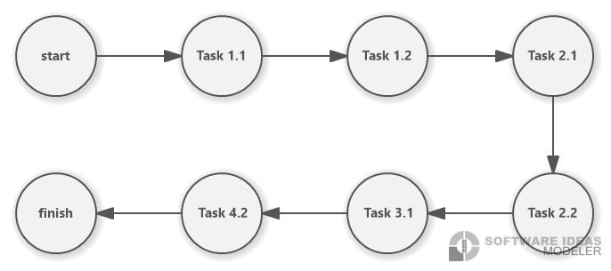

**Conclusion**

This project plan breaks down the design and implementation of the Grocery Store Billing and Inventory Management System into clear tasks and deliverables. The Entity-Relationship Diagram and Data Flow Diagram provide the foundational design, while the task list and critical path model ensure the project remains on schedule for successful delivery.